**Visualization in Databricks Notebook**

**Creating Databricks Resource:**

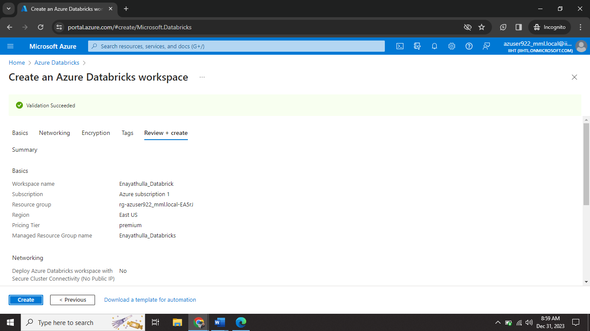

I created one databricks account (Enayathulla_Databrick) for performing visualization commands.

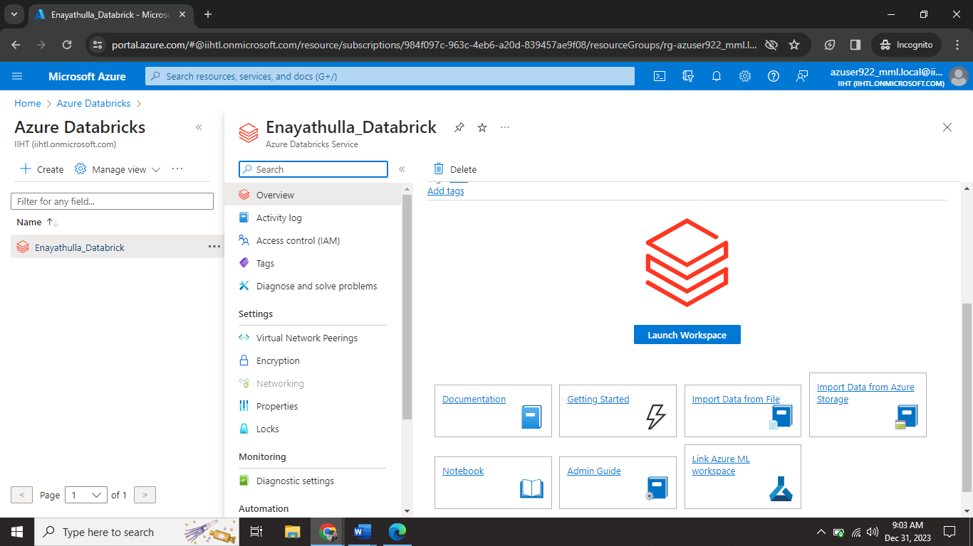

I launch the Enayathulla_Databrick using Launch workspace option.

**Creating Cluster:**

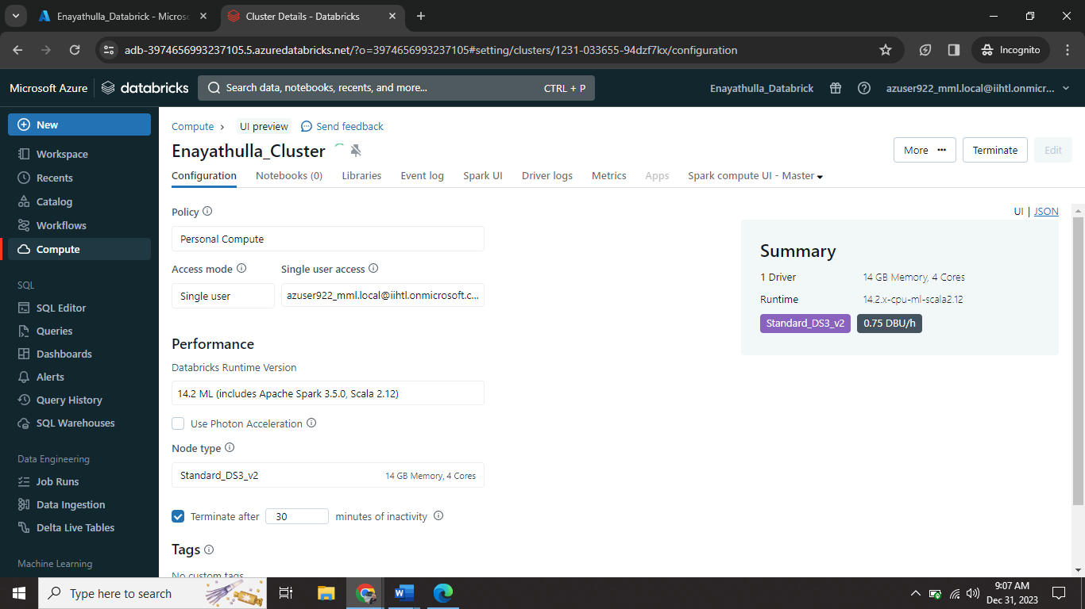

I created one cluster (Enayathulla_Cluster) on Enayathulla_Databrick workspace.

**Creating NoteBook:**

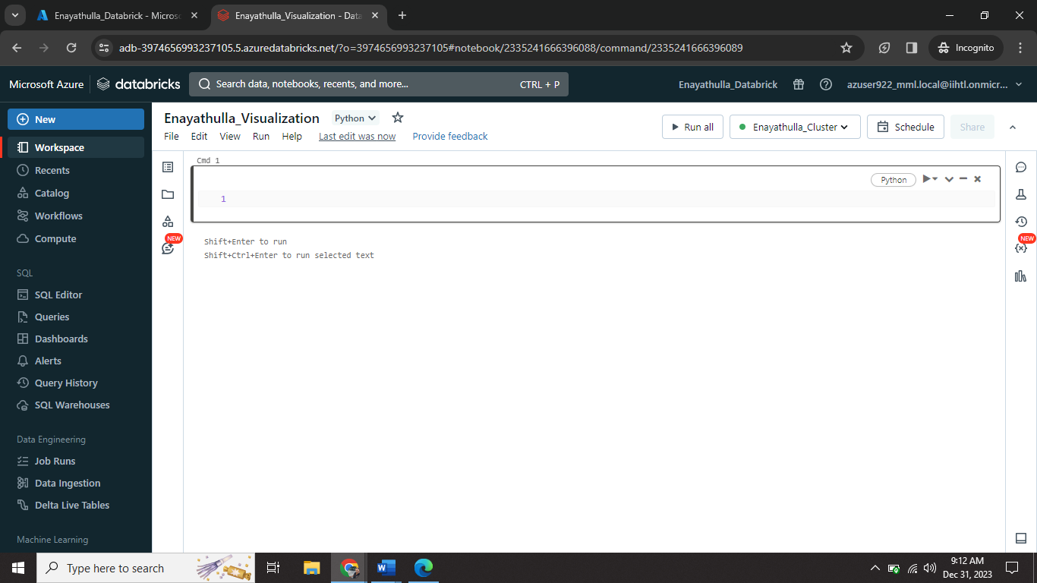

I created one notebook (Enayathulla_Visualization) on Enayathulla_Cluster.

**Perform operations:**

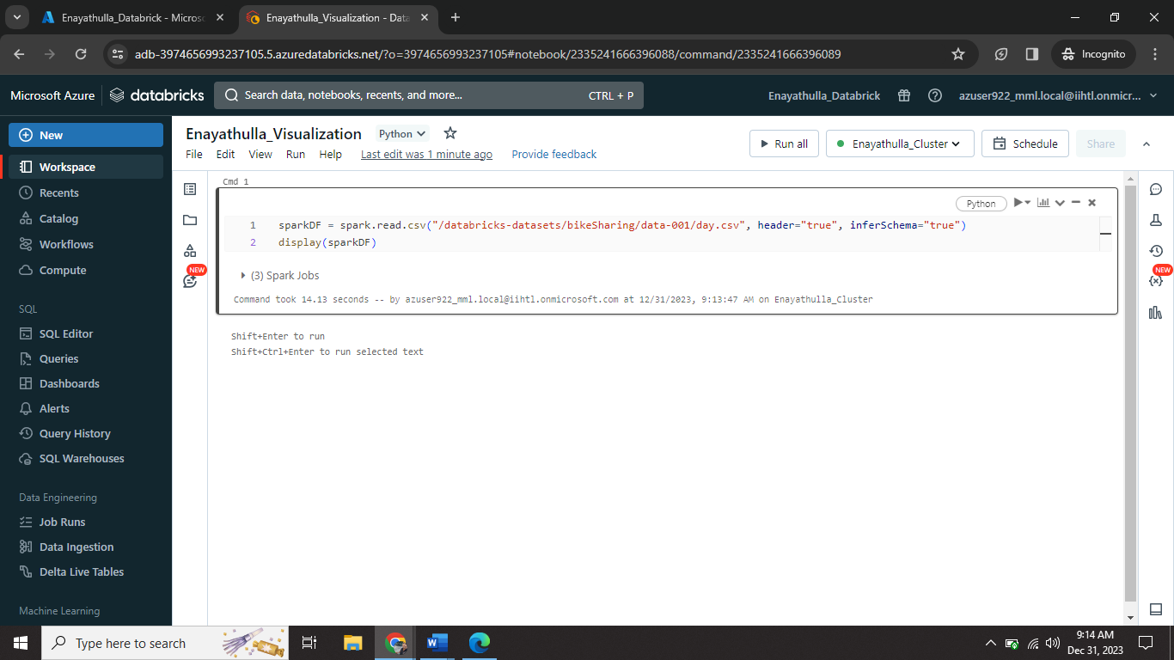

I ran one sample pyspark code on my notebook.

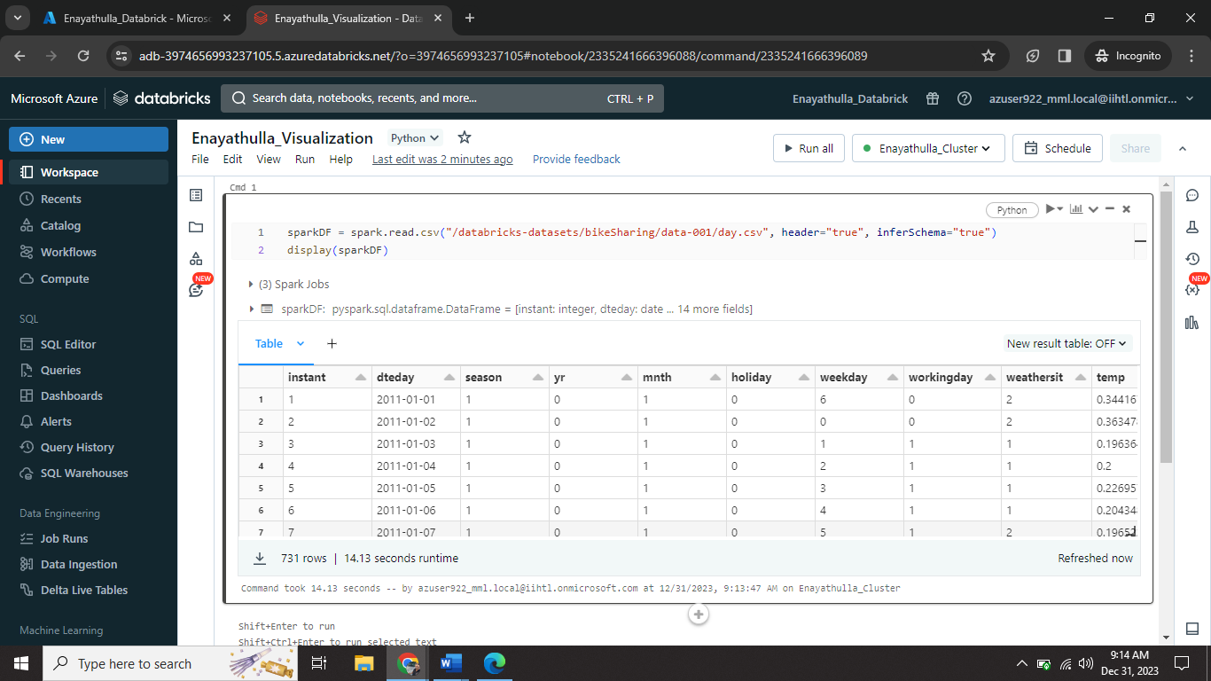

This is the output I got from the sample code.

**Visualization:**

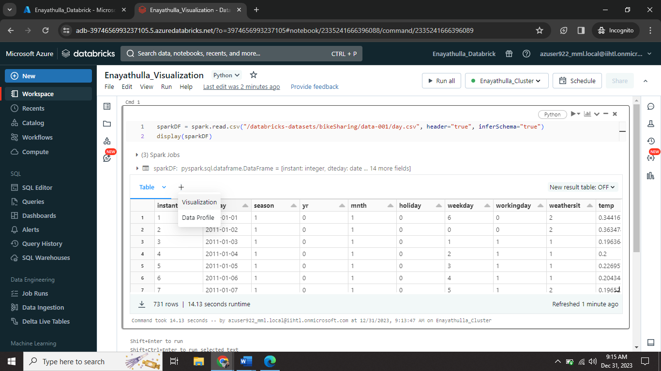

I click on Visualization tab for visualizing my table.

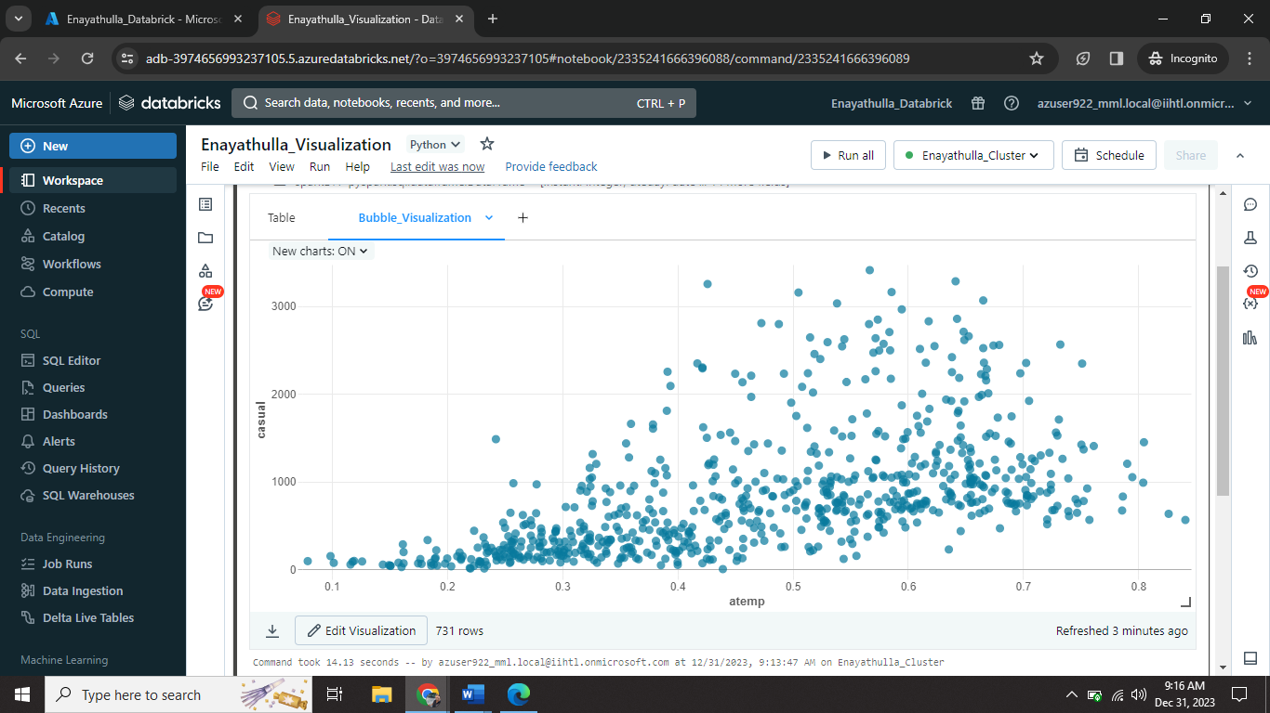

This is Bubble Visualization. (X-axis = atemp ; Y-axis = casual)

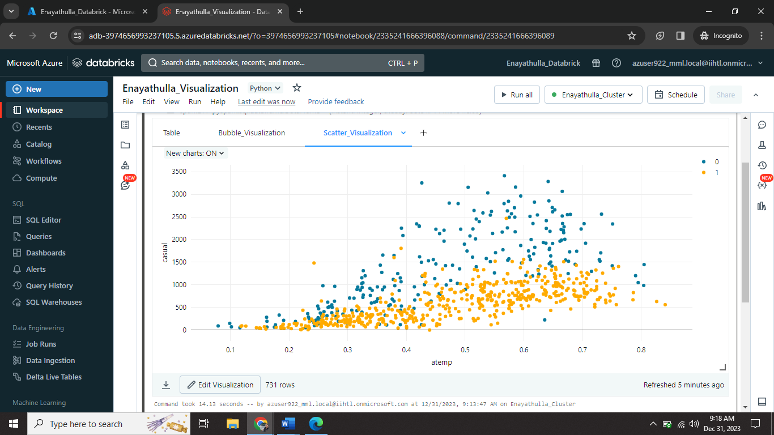

This is Scatter Visualization. (X-axis = atemp ; Y-axis = casual ; group by = workingday)

We can able to download the visualization.

**Data Profile:**

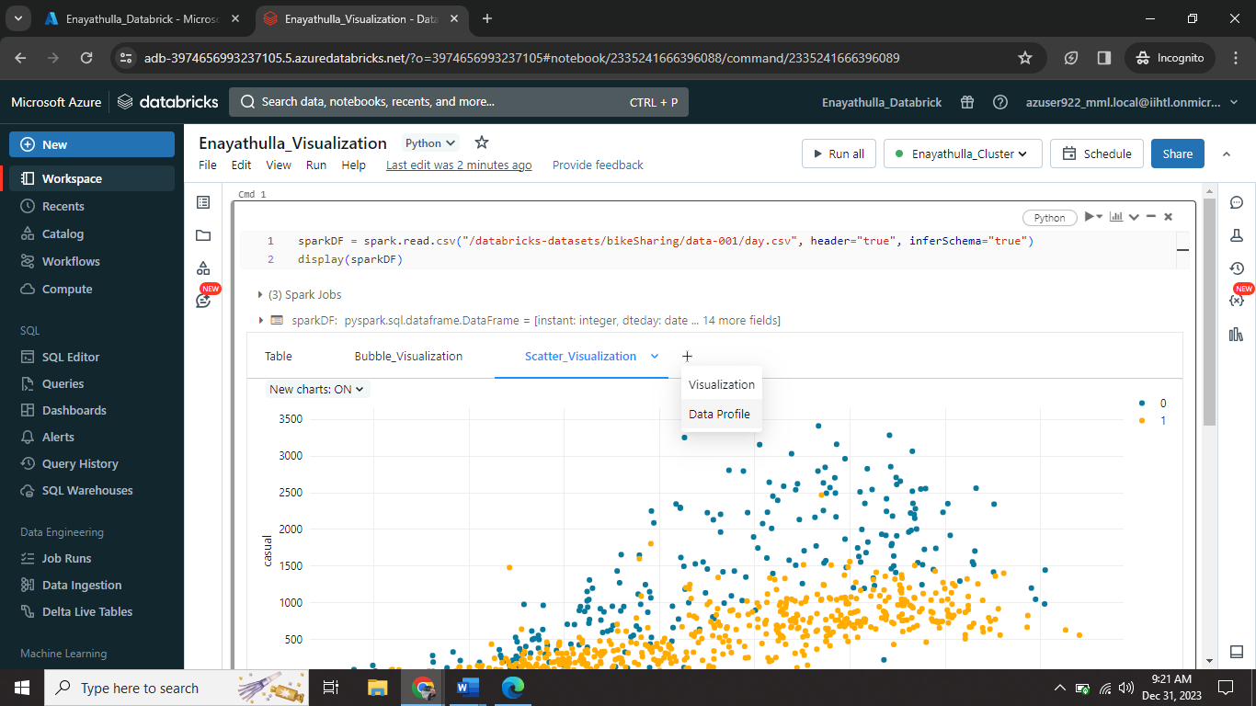

I created Data Profile using Data Profile Tab.

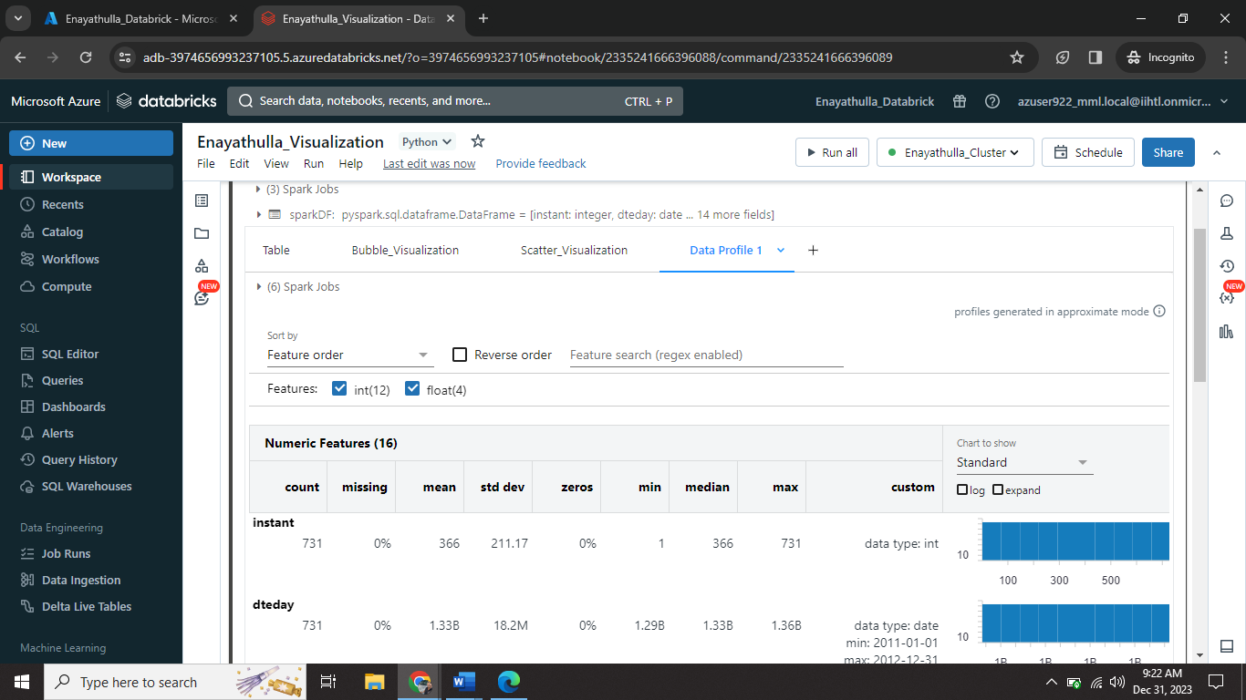

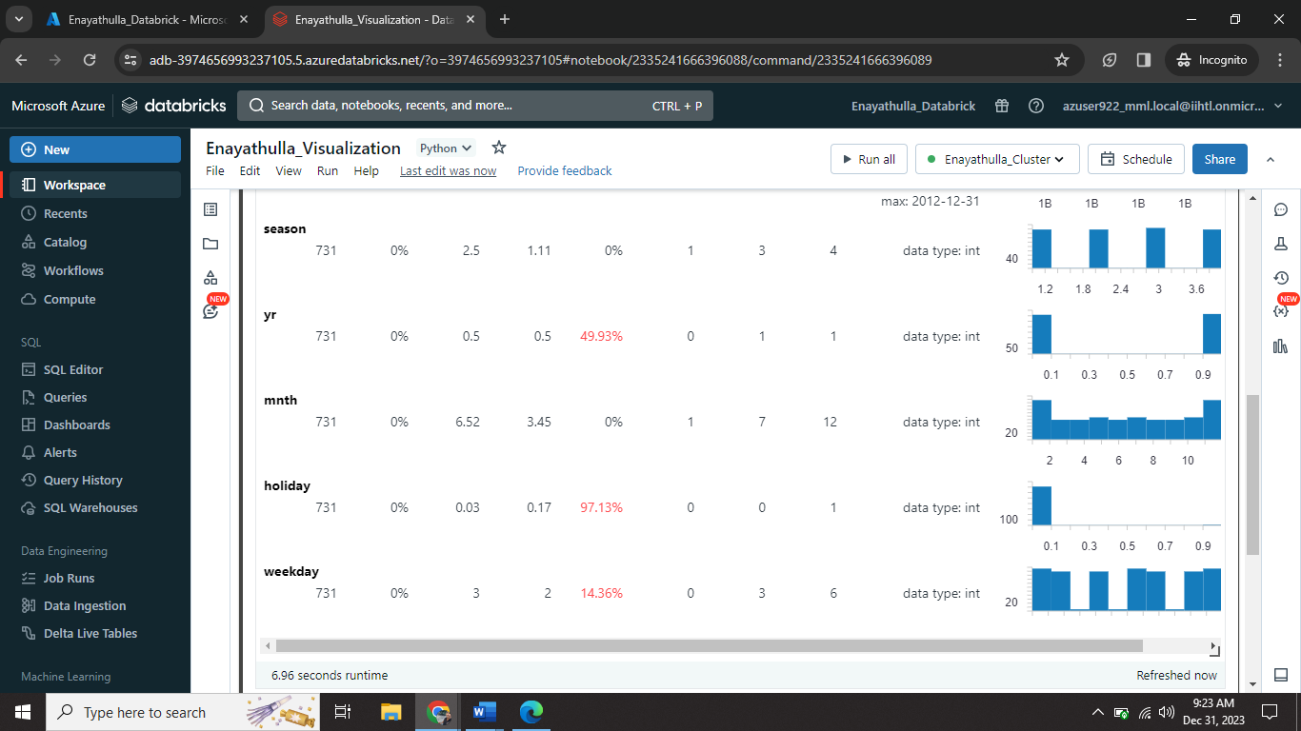

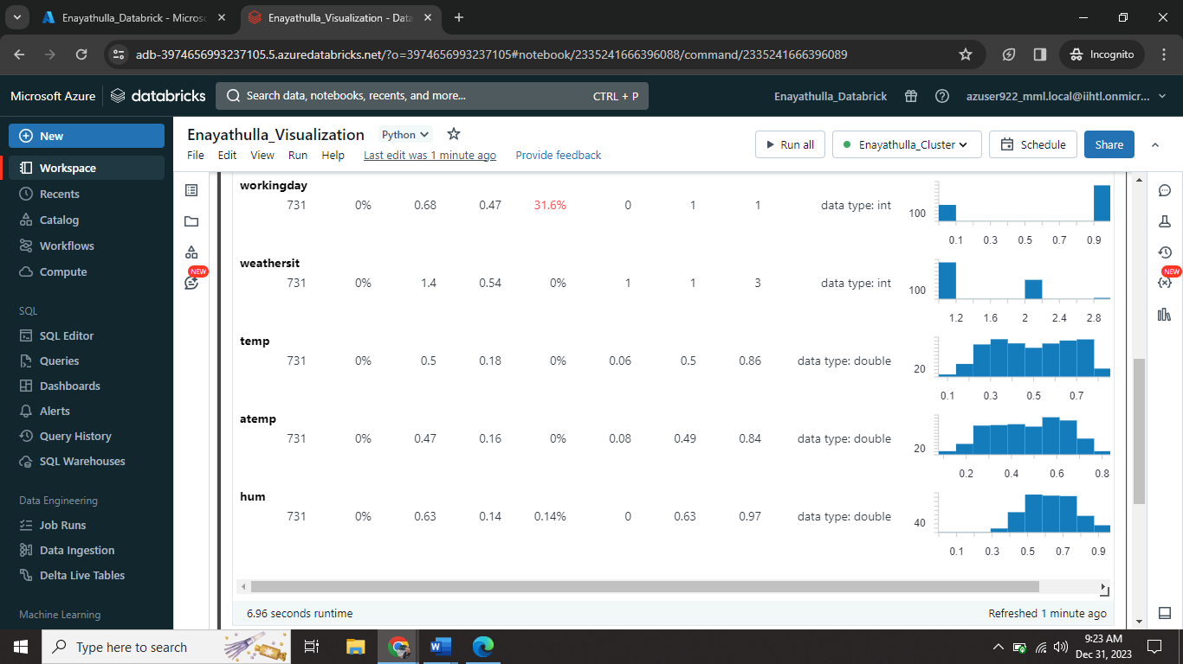

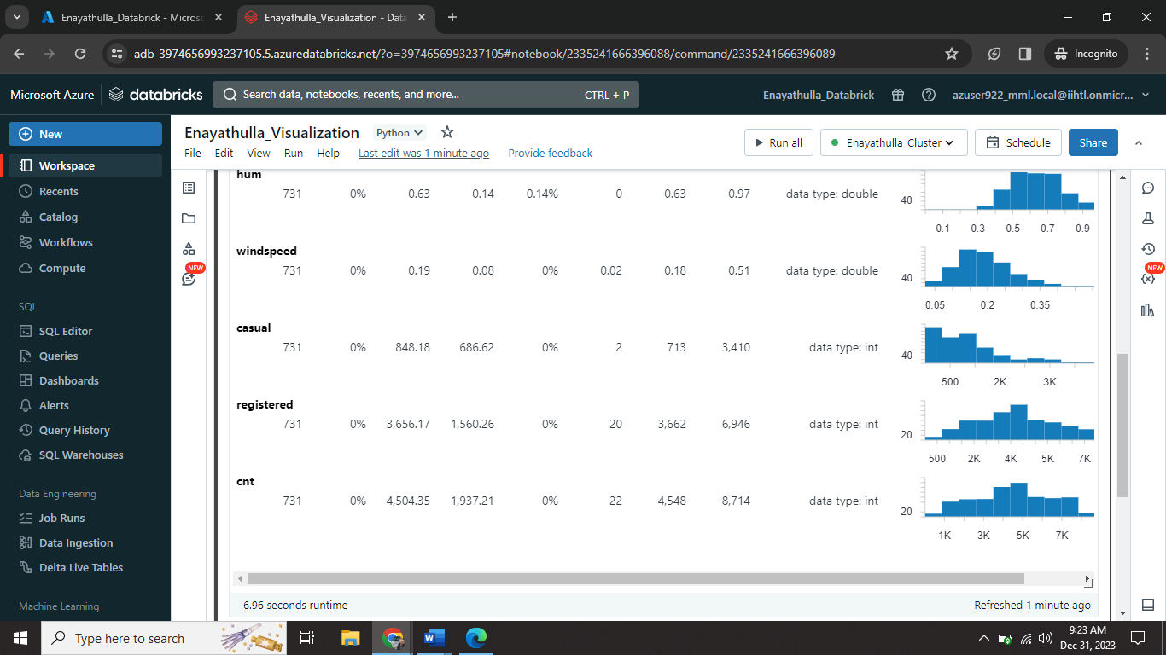

This is the output of Data Profile for that table.